Luis Morales
CSCI 4321 - Computer Security
October 13, 2025
Lab 06 – ARP Cache Poisoning Attack

Task 1 : ARP Cache Poisoning
1.A – using ARP requests
Entity | IP | mac
Attacker | 10.9.0.105 | 02:42:0a:09:00:69
Host A | 10.9.0.5 | 02:42:0a:09:00:05
Host B | 10.9.0.6 | 02:42:0a:09:00:06

Task 1.B – using ARP reply
Scenario 1: B’s ip is already in A’s cache. 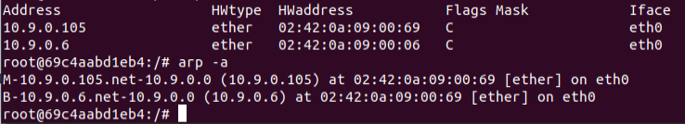

Scenario 2: B’s ip is not in A’s cache.
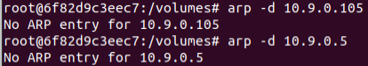
When arp was empty I received no results


Task 1.C – using ARP gratuitous message
Here is the arp result of using ff:ff:ff:ff:ff:ff as the destination

Task 2 :

Task 2 –

ARP poisoning 2 entries:
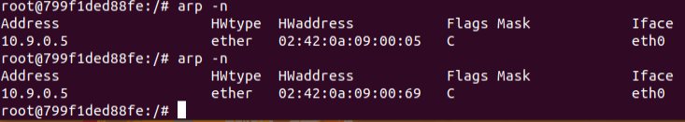
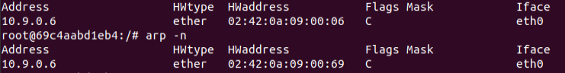
Using scaby I was able to detect icmp traffic from both hosts to the attacker and detected the source Mac as the attacker’s mac(which was set in the arp attack)

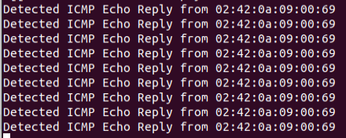

I learned how the ARP maps IP addressed to MAC addresses in local networks. Seeing how susceptible this authentication can be to spoofing is yet another eye opening experience to network security and its vulnerabilities. Once spoofed information is accessible to actors on the network.

